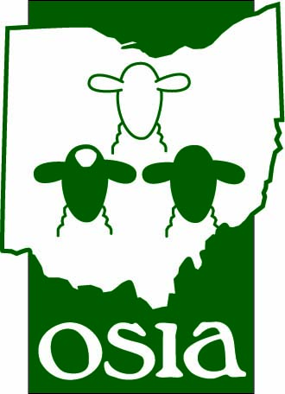
2012 Statewide Sheep Shearing School – September 14-15, 2012
Sponsored By: Ohio Sheep Improvement Association and OSU Extension
The Statewide Sheep Shearing School will be held Friday and Saturday, September 14-15, 2012 from 9:00 a.m.-4:00 p.m. at the Dave Cable Farm, 10491 Canal Rd., Hebron, OH 43025. No Class size limit and the cost is $40 per student which must be returned with registration form by Friday, September 14, 2012. If you decide to register after that date, please call Roger A. High at (614)246-8299. If you have further questions, please call Roger A. High at (614) 246-8299.
Lunch will be provided to those registrants that we have registered by the deadline date of Friday September 7, 2012.
Make checks payable to Ohio Sheep Improvement Association. Return bottom portion of this form with payment by Friday, September 7, 2012 to Ohio Sheep Improvement Association – Sheep Shearing School, c/o Roger A. High, 280 N. High St. P.O. Box 182383, Columbus, OH 43218. Applications will also be available at www.ohiosheep.org

- - - * Cut Here and Return Bottom Portion * - - - -

2012 Sheep Shearing School Registration Form – September 14-15, 2012

Name _________________________________________________________________
Address ________________________________________________________________
City ____________________________ State _________ Zip _______________
Phone _________________________________________________________________
Emergency Phone ________________________________________________________
(Please provide a cell phone number if possible in case we would need to contact you the prior to the school)
Shearing Experience (check one)
Beginner _______________ Intermediate _____________Advanced ______________
Payment of $40 per student is due with registration form. Make check payable to Ohio Sheep Improvement Association.

Disclaimer (must be signed): By signing this form I am hereby releasing the Ohio Sheep Improvement Association and any of its members of any liability for injury or accident as a result of participating in the Sheep Shearing School.

Signed: ____________________________________________Date _________________

