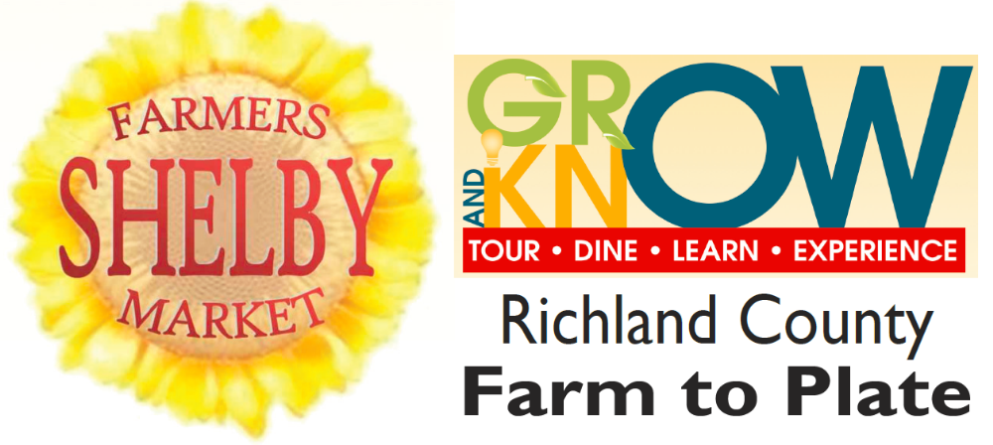

Demonstrations begin
At 10 a.m.

The Richland County Farm to Plate program would like to thank the following sponsors:
The growers and producers of the Shelby
Farmers Market
Hazel Grove
Farm Bureau
Community Council

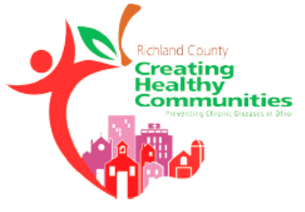

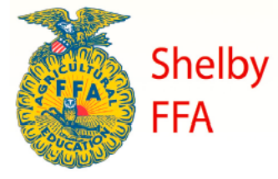
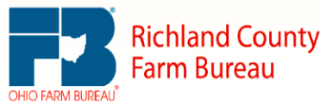
Announcing our September 13 Chef

Joseph Motter
Malabar Farm Restaurant
3645 Pleasant Valley Road
Perrysville, Ohio 44864

Special thanks to Richland Community Development Group and the Shelby Foundation
for funding this Farm to Plate experience

Stay tuned to
facebook.com/RichlandCountyFarmToPlate
and
richland.ofbf.org
for upcoming details

Market Money
Buy 6 tickets for $5.00
Spend them like cash at the farm vendors
Or to enter the “Personal Chef” Drawing

