Tricia Schoen
Helping the World Grow, Right Here
Lucas County Farm Bureau and the University of Toledo Team Up To Host Chinese Scholars.
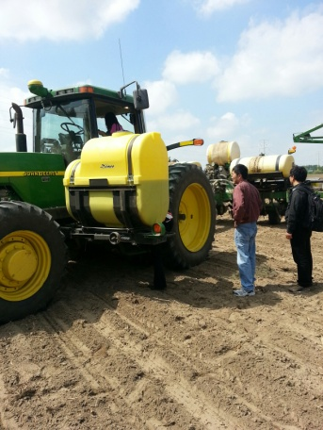
On May 13th, 2014 the Lucas County farm bureau hosted 12 Chinese Scholars by taking them to two farms in Lucas County to further their knowledge on American and Ohio agriculture. Dr. Gene Chang, Director of the Asian Studies Institute at the University of Toledo, reached out to the Lucas County Farm Bureau about this opportunity hoping the information learned at this event can be taken back to China with the scholars.
The day started at the owner of Whitehouse Specialty Crops LLC, Wade Smith's farm, with a presentation from Dr. Leah Dorman of Ohio Farm Bureau about Ohio and American agriculture. This was an eye opening discussion for the scholars. Dr. Dorman covered many areas such as, Ohio's agricultural rankings, the changing times and perceptions of animal agriculture, myths about agriculture, and GMOs (genetically modified organisms).
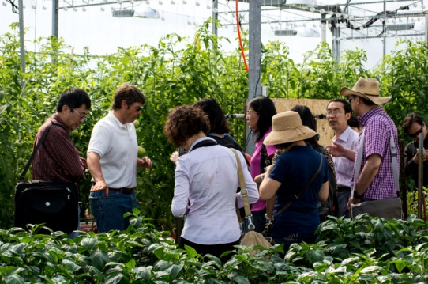
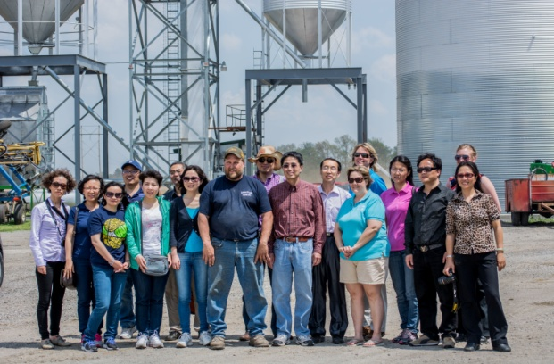
After Dr. Dorman's presentation, Wade Smith talked with the scholars about his farm and what he does. He specifically explained about the tomatoes he grows in his greenhouse all year round and how he focuses on the quality of his tomatoes, not quantity. After a short introduction Mr. Smith then gave a tour of his greenhouse to the scholars. Having many questions answered, the scholars had felt they grasped a whole new meaning on greenhouses and how they are making a positive effect in the agriculture industry.
The day then proceeded to a field where Lonnie Perry, a Lucas County farmer was planting. The scholars asked many questions relating to how and what he was planting. They also had the opportunity to see farming technology up close by being able to see inside the tractor and looking at the planter. As our agricultural industry has made huge leaps in its farming technology, the scholars were very intrigued and excited to see this technology up close and hope to learn more about it.
The Lucas County Farm Bureau then treated the scholars to some local food at the Whitehouse Inn where they had a casual lunch and continued talking about the agricultural industry in both America and China.
After lunch the scholars then visited the farm of Lonnie and Tracy Perry, also located in Lucas County. They discussed with the scholars their grain operation. They also showed the scholars their hogs, cattle and sheep that were located on their farm, answering any questions the scholars had about the animals or grain operations. The scholars were very happy to learn about the grain operation, as well as learning about the animal industry side of agriculture as well.
The Lucas County Farm Bureau would like to thank Dr. Cheng for reaching out to them about this wonderful opportunity, to Dr. Leah Dorman for coming and giving her presentation and to Mr. Wade Smith and Lonnie and Tracy Perry for opening up their farms during this busy time. It was a very successful event and the Lucas County Farm Bureau hopes there can be more events like this to come in the future.

