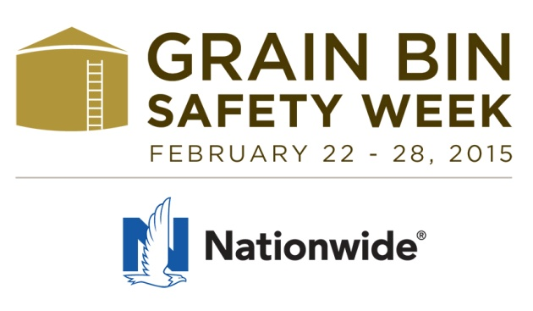

Help Your Fire Department Win Rescue Tube

Extremely high crop yields, combined with below-normal temperatures and a wet harvest have farmers, grain elevators and other grain handlers dealing with high-moisture corn and beans – and experts projecting the deadliest year for grain engulfment since 2010.

In 2010, 59 entrapments were recorded, resulting in 26 deaths – the highest number on record.

It takes only seconds to become helplessly trapped in flowing or moving grain, which acts like quicksand and can quickly pull a worker under and cause suffocation. Accidents in grain bins often result in multiple deaths when other workers attempt to rescue co-workers and become trapped as well.

“Every year, we see people needlessly injured and tragically killed in grain bin accidents that could have been avoided, says Doug Becker, Director, Nationwide. “In the wake of this year’s projection, it’s more important than ever for farm families, rural communities and industry leaders to come together to help prevent these tragic accidents from occurring.

Now in its second year, Grain Bin Safety Week (Feb. 22 – 28, 2015) is an annual observance dedicated to increasing the awareness of grain bin hazards and bringing visibility to the safe work practices and procedures to help reduce the number of preventable injuries and deaths associated with grain handling and storage.

Central to this year’s theme is the critical need for first responders to acquire the specialized rescue training and equipment needed to rescue someone entrapped in a grain bin. The chances of surviving an engulfment are greatly increased if a rescue tube is available to fire departments nearby.

Nominate Your Fire Department Contest
Contest period: Jan. 1 – May 31, 2015
In conjunction with Grain Bin Safety Week (Feb 22 – 28, 2015), Nationwide has partnered with the National Education Center for Agricultural Safety (NECAS), Grain Systems, Inc. (GSI) and KC Supply Co. to award fire departments with grain bin rescue tubes and specialized training to help save lives when farmers and other workers become entrapped in grain bins.

How to enter
Nominations can be submitted one of three ways:
- Online: grainbinsafetyweek.com/participate-with-us/nominate-your-fire-dept
- Email: agcontest@nicc.edu
- Mail: NECAS, Grain Bin Safety Ag Contest, 8342 NICC Dr., Peosta, IA 52068

To enter, describe how the fire department or emergency rescue team and rural community would benefit from receiving grain entrapment training and a rescue tube. Nominators must provide their name, occupation, phone number, mailing and email address; and the name, address and phone number of the fire department or emergency rescue team being nominated.

Official rules are available online at grainbinsafetyweek.com.

Other Grain Bin Safety Week Highlights

Daily Topics
Grain Bin Safety Week highlights a different topic or component each of the seven days. Articles are written by agribusiness risk management professionals, subject matter experts and other talented and experience people from agricultural backgrounds who understand the demands and risks of handling and storing grain.

#AgChat on Twitter
Nationwide, along with our partners Farm Safety for Just Kids and NECAS, will host #AgChat on Twitter 7-9 p.m. CT, Tues., Feb. 24. This moderated, online conversation will look at grain bin safety from different angles and generate insight from folks involved in the business of growing food, fuel, feed and fiber. Anyone with a Twitter account can participate. Go to tweetchat.com and enter #agchat to start. The site automatically enters the #agchat hashtag in every tweet and allows users to participate in real time.

Webinar – Grain Bin Safety
During the week, Nationwide will host free, live webinars on grain bin safety that are open to everyone. Taught by subject matter experts and industry professionals, these webinars will provide farmers and commercial grain handlers with valuable insight into grain management, personal protective equipment, bin entry, rescue equipment and more. Registration will open soon!

For more information about or to participate in Grain Bin Safety Week, go to grainbinsafetyweek.com or follow Nationwide Agribusiness on Facebook, Twitter or YouTube.

# # #

About Nationwide
Nationwide, a Fortune 100 company based in Columbus, Ohio, is one of the largest and strongest diversified insurance and financial services organizations in the U.S. and is rated A+ by both A.M. Best and Standard & Poor’s. The company provides a full range of insurance and financial services, including auto, commercial, homeowners and life insurance; public and private sector retirement plans, annuities and mutual funds; banking and mortgages; specialty health; pet, motorcycle, and boat. It is the #1 farm insurer* in the country, and a leading insurer of commercial agribusiness and related businesses in the food, fuel and fiber chain. For more information, visit nationwideagribusiness.com.

*Source: 2013 Munich Re Report. Based on premium and loss data. Nationwide and the Nationwide N and Eagle are service marks of Nationwide Mutual Insurance Company. © 2014 Nationwide Mutual Insurance Company.

