Green Energy Ohio presents…
Do Your Homework While Investing in Renewable Energy
Monday Evening, July 6, 2015, 7:00 to 8:30 PM
GEO Southwest Ohio Clean Energy Network Meeting
Edison Community College
Room 503, 1973 Edison Drive, Piqua, OH 45356
Free to the Public
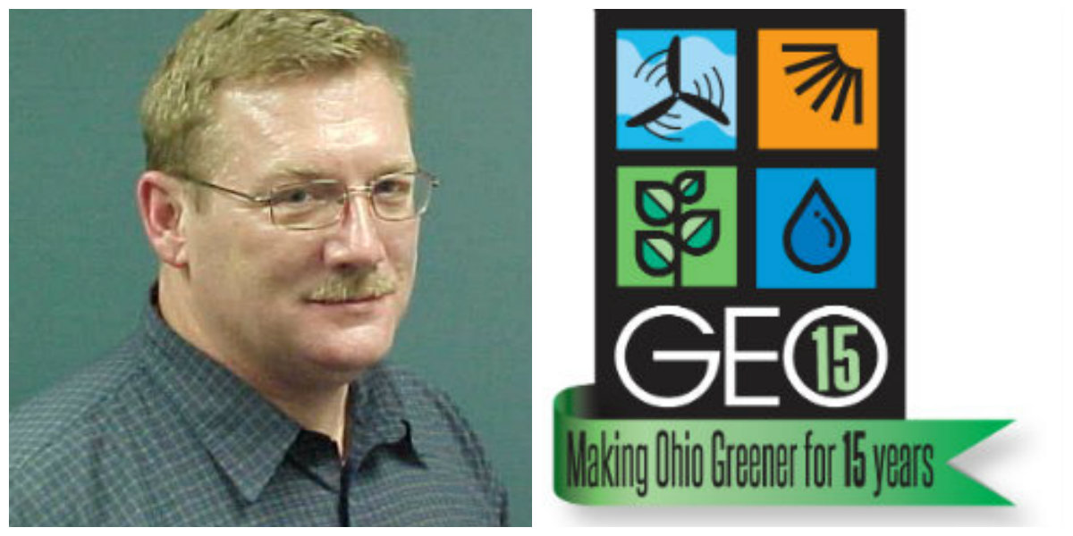
Join GEO to hear Ohio Farm Bureau Federation’s Energy Expert Dale Arnold discuss how advances in technology have made renewable energy equipment, particularly for solar and wind, more practical than it was just five to 10 years ago. Farm, small business and residential energy consumers looking to invest in this technology need to think the same way as they would when purchasing a major piece of farm equipment or real estate.

