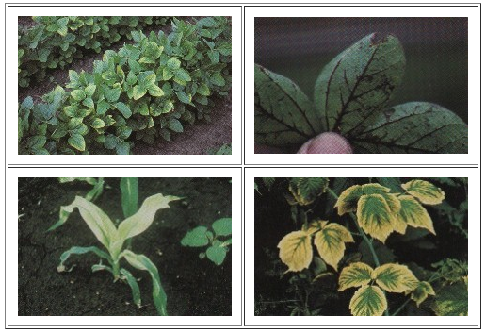
OSU EXTENSION – AUGLAIZE and MERCER COUNTY
Spray Diagnostics Field Day

July 14, 2016

10 am -
12 Noon

Please Register by
July 7, 2016

Auglaize County Extension
Jeff Stachler
419-739-6580
Email: stachler.1@osu.edu

Or

Mercer County Extension
Denny Riethman
419-586-2179
Email: riethman.24@osu.edu

Field Day Will Include:
- Plot Demonstrations
- Modes of Action Symptoms
- Spray Drift Demonstration
- Tank Contamination and Cleanout
- Spray Nozzle Selection

Location:
14739 Kruse Road, Wapakoneta, OH

Cost:
$10.00

CCA and CPAT Credits will be applied for.
CFAES provides research and related educational programs to clientele on a nondiscriminatory basis. For more information: http://go.osu.edu/cfaesdiversity.
To register for testing, go to www.pested.osu.edu

Testing date: Dec 14th – 10 am
Central Services Building-1st Floor Meeting Room

