2017 APPLICATION
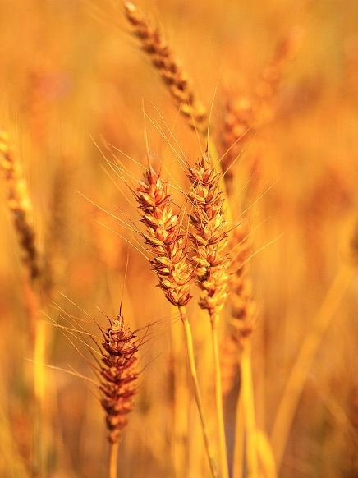

COLLEGE SCHOLARSHIP

The Athens-Meigs Farm Bureau and Bickle Insurance Services are pleased to announce that we will be awarding two (2) $500 college scholarships for the 2016-2017 academic year. The deadline for entry is April 7, 2017. We would like to announce the recipient of the scholarship prior to high school graduation. The scholarship will be distributed directly to the applicant upon proof of college incurred expense (i.e. tuition, books, etc). Please mail the completed form to the address below. If you have any questions please call the Athens-Meigs Farm Bureau at 740.286.4598 or 1.800.777.9226.

Guidelines

 The application must be typed
 Applicant must be a senior in high school
 Special preference will be given to applicants planning to study in an agriculturally related field
 Please supply an official grade transcript from your most recent year of education
 Please supply a photo along with your application
 Mail to: Athens-Meigs Farm Bureau, 231 Broadway St., Jackson, OH 45640

Application You may supply a separate typed page to respond

Name:

Address:

Phone: Parents Name:

High School: Cumulative GPA:

Are you or your family members of the Athens-Meigs Farm Bureau?  Yes  No

College attending or will be attending:

Current / Planned Major(s):

Please List other forms of financial aid you have already received or will be receiving for the 2016-2017 academic year:

How do you plan to finance your college education?

What are your future career plans?

Please answer the following questions. You may supply one (1) additional typed page to supply your answers not including the resume.
- Why should you be chosen as the recipient of the Athens-Meigs Farm Bureau scholarship?

2. Please supply us with a one (1) sheet resume which outlines your academic achievements, involvement in extra and co-curricular activities and community service and involvement.

Signature: Date:

Mail this complete application to: Athens-Meigs Farm Bureau, 231 Broadway St., Jackson, OH 45640

Due or post marked by April 7, 2017

