Lucas County Farm Bureau
And
Lucas County Soil and Water
Invite you to attend
Nutrient Management Day

April 6, 2017
Bass Pro Conference Room
10000 Bass Pro Blvd, Rossford, OH 43460
10:30 AM – 1:30 PM
Topics included:
- Nutrient Management – John P. Fulton, Ohio State University Associate Professor.
- 360 Soil Scan research with information being presented by local SWCD which will include testimony by current users.
- Soil Biology – Local Farmer, Ron Snyder.

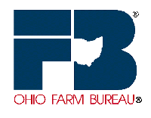
Lunch is included
RSVP on or before March 30 by contacting the Farm Bureau
800-333-8015
Seating is limited!

