Sponsored by Highland County Farm Bureau & Five Points Implements Co. Inc.
Friday, April 28, 2017
6 p.m. – 8 p.m. @ Five Points Implement Co. Inc.
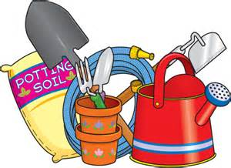
Featuring Demonstrations on
Gardening by the Highland County Master Gardeners Club
Canning demo by
Garden Equipment Maintenance by John Deere Techs

Tickets: $20* @ the door the night of the event
Pre-Sale tickets can be purchased for $15* @ Five Points Implements Co. or First State Bank
*Farm Bureau members receive $5 discount. Must show membership card to receive discount.

Chinese Auction featuring 5 themed baskets. Raffle tickets will be sold @ the event.
Members that show their membership card @ the door will receive 5 raffle tickets.

Vendors on display @ the event include:
Clever Containers / Keep Collective / Lula Roe / Kreations by Kara / Mary Kay Norwex / Origami Owl / Pampered Chef / Perfectly Posh / Rodan+Fields / Scentsy Tastefully Simple / Thirty-One / Young Living Essential Oils / Younique

Join us for the evening while you mingle with friends, shop our local vendors, learn something new about gardening & support Highland County 4-H.

