Sandusky County Farm Bureau
109 Portage Street – Woodville, OH 43469
(419) 849-2128 / 800-333-8015
sandusky@ofbf.org

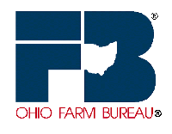

Sandusky County Farm Bureau invites you to attend a
Grow and Know Ag Tour
Saturday, August 12, 2017
A chartered bus farm tour hosted by the Farm Bureau will stop at three local agricultural businesses in Sandusky County:

King Dairy
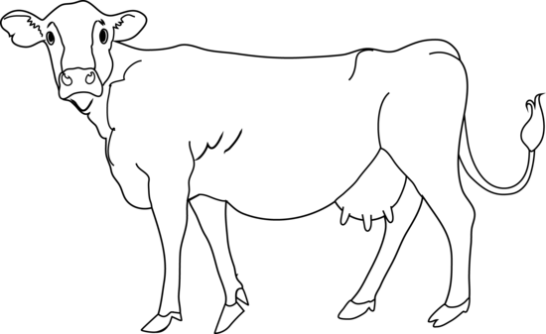
To make your reservation please contact the Sandusky County Farm Bureau office:
(419) 849-2128
or email
sandusky@ofbf.org by August 1.
This is a free event for all Farm Bureau members.
Cost is $10 for non-members.
Agenda:
8:30 am – board bus at Potter Village Shopping Center
9 am – Depart for tour which will begin with Polter’s Berry Farm followed by a visit to King Dairy and conclude with a boxed lunch and tour at Sunrise Cooperative.
2 pm – return to Potter Village Shopping Center

