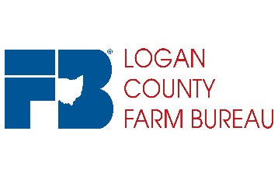
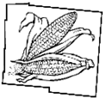
110 Industrial Dr.
Suite C
Wapakoneta, OH 45895
877-775-7642
www.ofbf.org/counties/logan
Logan County
Agriculture
Impact Fund

Logan County Agriculture Impact Fund Grant Application

About: The Logan County Agriculture Impact Fund was founded in 2018 to provide agriculture enrichment opportunities to the youth of Logan County. The grant was established by the Logan County Farm Bureau and the fund is generated through reverse raffle event.

Purpose: The grants are in amounts of up to $20,000 for the enrichment of youth in agriculture in Logan County Ohio. The purpose of the fund is to support projects and events that will expand and grow agriculture’s footprint in the county.

Eligibility: Grants are offered to any organization in Logan County Ohio that promotes the wellbeing, and enrichment of youth involved in the agriculture community of our county. The grant will be evaluated on a competitive basis. Projects submitted for the grant MUST be completed by 2020 year end.

Grant Timeline:
- Applications will be due October 18, 2019
- Upon submission grants will go through two approval committees. Recipients will be notified by December 1, regarding their success in the application process.
- Completed project reports will be due to the committee by November 30 the following year and final payment will be processed.

Application Guidelines:
- Grant must be submitted electronically by deadline. No paper submissions will be reviewed.
- Applications must be received by October 18.
- Those projects selected for grants will receive one-half of the grant at the beginning of the project and the balance upon completion of the project and submission of a final report to the Impact Fund committee regarding the success of the project.
- An organization may only submit 1 application in a cycle.
- Funding is not available for mileage, wages/benefits, meals and preference will be given to those projects that create a long term impact.
- Grant payments can only be made to organizations that are 501c3. Payments CANNOT be made to individuals or to other organizations.

Selection Criteria:
All applications MUST be for agriculture improvement programs. All applications will be screened for compliance to the grant proposal guidelines, and any grant that does not meet the guidelines will eliminated from the judging process prior to review. The following areas are eligible for disqualification:
- Applicant failing to follow directions.
- Applications submitted past deadline.
- Application not meeting basic requirements as an agriculture supporting program.

All applications meeting the guidelines will be evaluated by a panel of judges. Each evaluator will be asked to score the applications according to the following criteria:

The project enhances the agriculture community of Logan County Ohio | 30 Points
The project will engage youth and encourage their involvement in and to learn more about agriculture. | 20 Points
The projects application is complete and has defined: Plans, Goals, Timeline and Budget. | 20 Points
Project fills a current need or void in the community. | 20 Points
The project expands on current agriculture efforts being done currently in the community. | 10 Points

Applicant Information

Applicants Name/Organization: ___________________________________________________________

Tax ID number:________________________

Address: ______________________________________________________________________________

City: _____________________ State: _______ Zip: ____________

Contact Person with Organization: _____________________________________________

Contact Person Phone: ______________________________ Email: _______________________________

Grant Funding Request Amount :___________________________________( minimum of $100.00)

Project Summary: Please keep to 125 words/characters

What are the goals and anticipated outcomes for your project?

Who is your target audience? How many will you reach with this project?

What is the timeline for your project?

What is your budget/how will be it used?

Explain how this project will engage, enlighten and grow agriculture awareness in our community.

