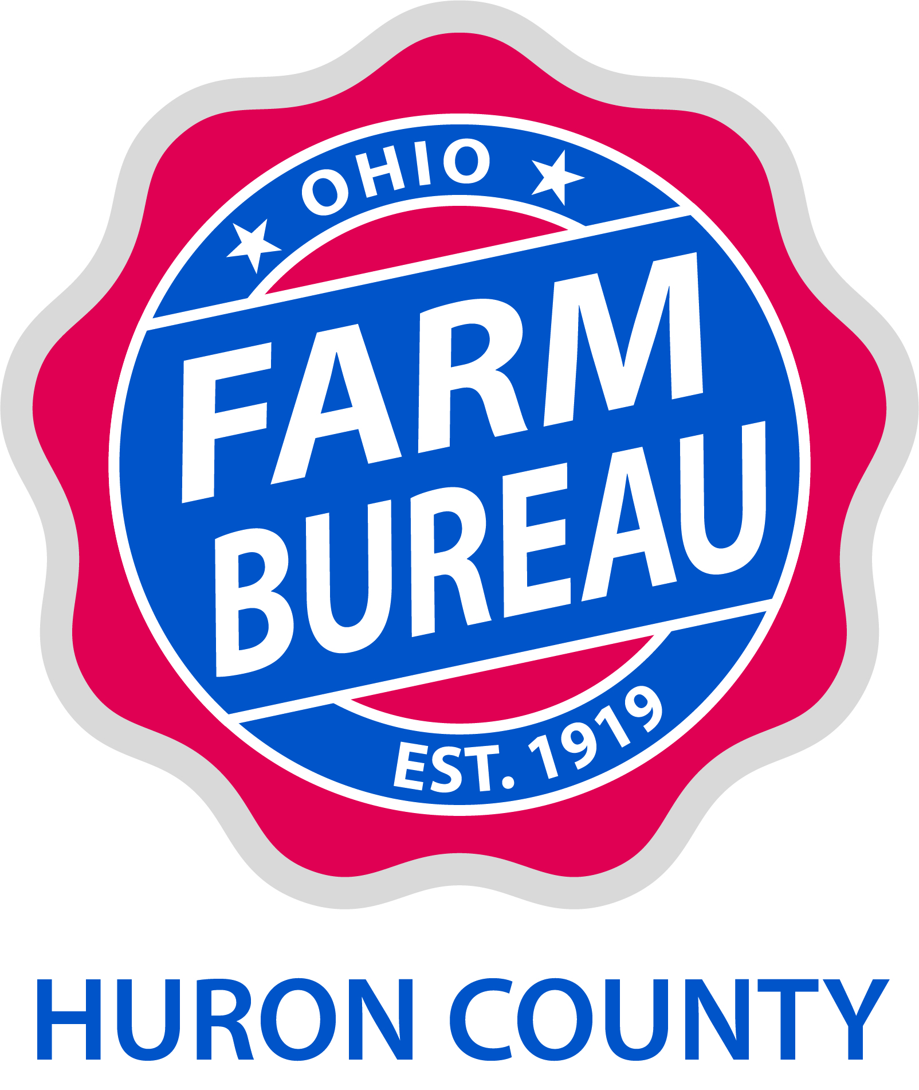

January 2021

TO: All Teachers in Huron County

RE: Teacher’s Grants

The Huron County Farm Bureau will sponsor grants from $25 to $250 to teachers from any grade level in a Huron County School. The total amount awarded countywide will be up to $1,250.00.

The grant is for the teaching of agriculturally related subjects. Agriculture is defined as ‘the science, art or occupation concerned with cultivating land, raising crops, and feeding, breeding, and raising livestock; farming, the production of crops, livestock or poultry, or agronomy’. Some sample lesson ideas are technology in agriculture, agriculture safety, maximum farmland usage, and the effects of global warming on crop production. Some suggested uses for the grant money would be books, videos, lab materials, workshops, or field trips.

Completed applications need to be returned by March 31, 2021 to:

Huron County Farm Bureau
8460 Ridge Road
North Royalton, OH 44133

Please distribute to all elementary, middle and high schools teachers. If additional forms are needed, please feel free to make copies or contact the Farm Bureau office at (440) 877-0706 or visit huron.ofbf.org.

Sincerely,

Jamie Hilaman
President
Huron County Farm Bureau

Enclosure: Teacher’s Agriculture Grant Application

Huron County Farm Bureau, Inc.
Teachers Agriculture Grant Application
Due March 31, 2021

Name:

School:

Mailing Address:

Grade or class this lesson is for:

Objective:

Briefly describe this lesson:

Materials needed, with cost:

Total Cost:

How is this lesson related to agriculture?

Return to: Huron County Farm Bureau, 8460 Ridge Road, N Royalton OH 44133 by March 31, 2021

