Sponsorship For
Harvest for Hunger

Yes, I am interested in sponsoring the event for 2022 in the following way:

Gift certificate from local business or service

Donation of an item for the auction

Monetary Donation (check payable to Holmes County Farm Bureau)

Donation of an item for a raffle

Name of Sponsor:

Address:

City, State, Zip:

Would you like a committee member to pick up your donation? Yes OR No

Daytime Phone:

Best time to call to arrange pick up?

What is the approximate value of your donation?

Email:

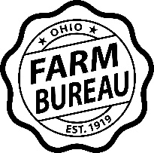
Thank you for sponsoring!
Please remit to:
Holmes County Farm Bureau
377 West Liberty Street
Wooster, OH 44691

